Project Status: GPL Sampling Method

- Project Background

Each GPL pool can be viewed as consisting of a single loan. The standard OAS pricing framework uses a “continuous” (or “fractional”) approach to generate prepayment rates along each interest rate path for each GPL pool.
An alternate approach is to treat each prepayment “discretely” so that at each time step, the pool/loan survives, voluntarily prepays, or defaults. For each continuous path of prepayments, the discretization approach will require many simulations to “converge” in probability. The discretization can be made to converge to the true probability more quickly by sampling using quasi-random numbers.

- Necessary Components

In order to implement the concept of discrete method, and have the result converge to the true probability, we need the following building blocks:

- Random number generator
Quantlib provides us two types of random number generators: pseudo random generators (Mersenne Twister) and quasi random generators (Sobol Sequences). One can find more detailed information about the topic in: A note on random number generation

Briefly, pseudo-random sequences typically exhibit statistically randomness while being generated by an entirely deterministic process.These random numbers have high-discrepancy. On the other hand, the quasi-random numbers are not really random either and do not perform well in statistical tests of randomness. The main advantage of a quasi-random sequence in comparison to a pseudo-random sequence is it distributes evenly hence there are no large gaps and no formation of clusters (see the diagram below).

Since we want to use a sampling method in Scale that can converge to the true probability quickly we need to implement the Sobol Sequence method provided by Quantlib.
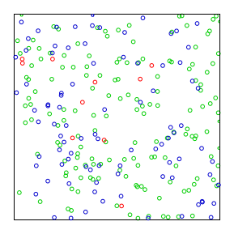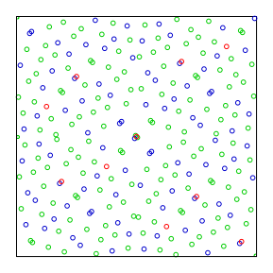
Example of Pseudo-random (Mersenne Twister) and Quasi random generator (Sobol Sequences)

We now present a stylized outline of a multi-step Monte Carlo simulation for GPLs

- Generate a path of interest rates
  - For each pool/loan
    - For each month
      - If the loan has not defaulted, prepaid, or fully amortized
        - Calculate the loan-level probability of default, d
        - Calculate the loan-level probability of prepayment, p
        - Perform a multi-step simulation
          - Generate a uniform random number, u, in the range (0,1)
          - Determine whether the loan defaults this month (u <= d)
            - If default, mark loan as defaulted and generate full payoff
          - Determine whether the loan prepays this month (d < u <= d+p)
            - If prepaid, mark the loan as voluntary prepayment and generate full payoff
      - End If
    - End of month
  - End for each loan
- End for each interest rate path

- Current Project Status

To take the project to the next level we have to execute the following improvements:

- Improve Random Number Generation

Our current approach relies on generating numbers using the Mersenne Twister algorithm. We need to improve the convergence process by using quasi-random numbers from Quantlib. We also need to investigate how to use “seeds” for the random number generation process.

- Refactor code to produce OAS estimates

- Objectives:

- On each path, improve the agreement between continuous probabilities and the sampling probabilities
- On each path, check that cash flows produced using continuous probabilities “match” (for the appropriate CMO structures) the ones produced sampling probabilities.
- Across all sampling paths, at the same price as before, how different is the OAS? This gives you a sense of the idiosyncratic risk of this bond.

The discrepancy of a sequence of points in the unit d-dimensional cube compares the actual number of points in a given volume with the expected number of point in that volume, assuming that the sequence is uniformly distributed in the cube.
Using the prepayment model.
At this time, we are still experimenting with the optimal number of simulations required to produce an acceptable rate of convergence to the appropriate probabilities.

